Module Code: BMM6004M
Module Leader(s): Dr Paul Stallard
Assessment format: Individual Report

Patagonia’s International Marketing Strategy: Sustainability, Culture, and Anti-Growth Global Expansion

Table of Contents
1. Introduction 3
2. International Marketing Environment and Scope of Activity 3
2.1 Global Presence and Market Scope 3
2.2 Industry Context: Global vs Multidomestic 3
2.3 Drivers of Internationalisation 3
2.4 International Marketing Environment 3
3. Internationalisation Strategy and Market Entry 4
3.1 Internationalisation Path 4
3.2 Market Entry Modes 5
3.3 Market Selection Strategy 5
References 7

1. Introduction
The term international marketing strategy means conceiving and implementing marketing past national boundaries (Solberg and Durrieu, 2022). Patagonia can be found in 43 out of the 69 markets across the globe who operates within the outdoor sports apparel (ECDB, 2026). The report critically evaluates the strategy of Patagonia on the basis of international marketing theories and models. It uses the Uppsala model, OLI paradigm, and cultural models in a comparative approach. The report assesses the theoretical applicability, weaknesses, and market implications.

2. International Marketing Environment and Scope of Activity

2.1 Global Presence and Market Scope
Patagonia has presence in North America, Europe and the Asia-Pacific markets worldwide. In 2025, the revenue amounted to 4.17 billion dollars (Patagonia, 2025). It has its major markets in North America, with 57% of revenue, Germany, the United Kingdom, France, and Japan (ECDB, 2026). The company has seventy stores and Salesforce Commerce Cloud and Shopify applications.

2.2 Industry Context: Global vs Multidomestic
Patagonia embodies the features of the global industry and multidomestic industry at the same time. The values of sustainability are always uniform across the world, enhancing a uniform brand identity all over the world. The marketing strategies, however, are locally adjusted in the Japanese, German market and French markets. This amorphous form confronts the classical global/ multidomestic systems. Theory generalises strategies on the international level and does not consider cultural responsiveness requirements.

2.3 Drivers of Internationalisation
Market forces are an increasing number of eco-conscious consumers in Europe and the Japanese markets. In 2025, the online channels facilitated 38.6% sales (Dataintelo, 2026). Competitive drivers entail differentiation in contrast to Nike and Adidas sustainability positioning throughout the world. Some of the technological drivers are the faster growth of e-commerce since 2020 (Au-Yeung, 2020). Patagonia does not focus on forceful growth plans around the world but on moral congruency.

2.4 International Marketing Environment
Germany and the sustainable apparel market in Sweden demand is influenced by cultural diversity. European regulatory frameworks are pro-sustainability, compliance, and ethical sourcing. The high-population developing markets around the world have economic variation as a hindrance to the accessibility of premium pricing. Controlled distribution limits the availability, which is less scalable. Nevertheless, this will maintain exclusivity and reinforce brand positioning with the eco-conscious consumer all over the world.

3. Internationalisation Strategy and Market Entry

3.1 Internationalisation Path
Patagonia pursues step-by-step globalisation on the route of expansion of the Uppsala models. It started venturing out of the United States towards markets in Western Europe first. Entry U.K.<|Germany|>Fragmentation United Kingdom Germany France had less psychic distance. The expansion is over seventy physical stores all over the world (Patagonia, 2026) and digitalisation. Turnover online will be US629million 2025 (ECDB, 2026). Nevertheless, it is arguable that incremental dependence is mitigated in online growth.
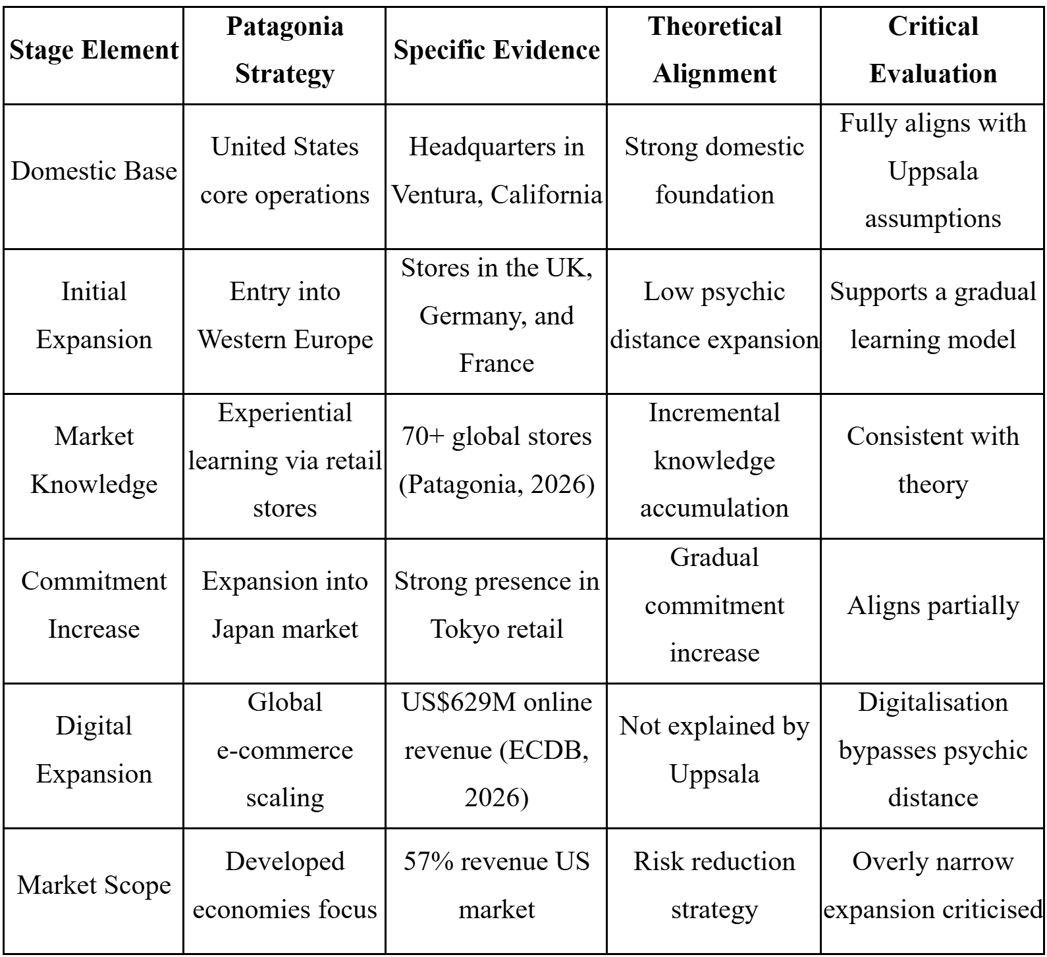
Table 1: Staged International Expansion under the Uppsala Model
(Source: Author)

3.2 Market Entry Modes
Patagonia operates with wholly owned subsidiaries and direct to consumer in the global markets, having complete control over its activities in other countries and 100% first-party online sales (ECDB, 2026). This is indicative of high ownership and internalisation benefits as discussed under the OLI framework, whereas sustainability concerns always dominate the logic of cost minimisation of the Transaction Cost Economics across markets. This is in line with ECDB (2026), where it was realised that the organisation earned US$629 million in online revenues worldwide.
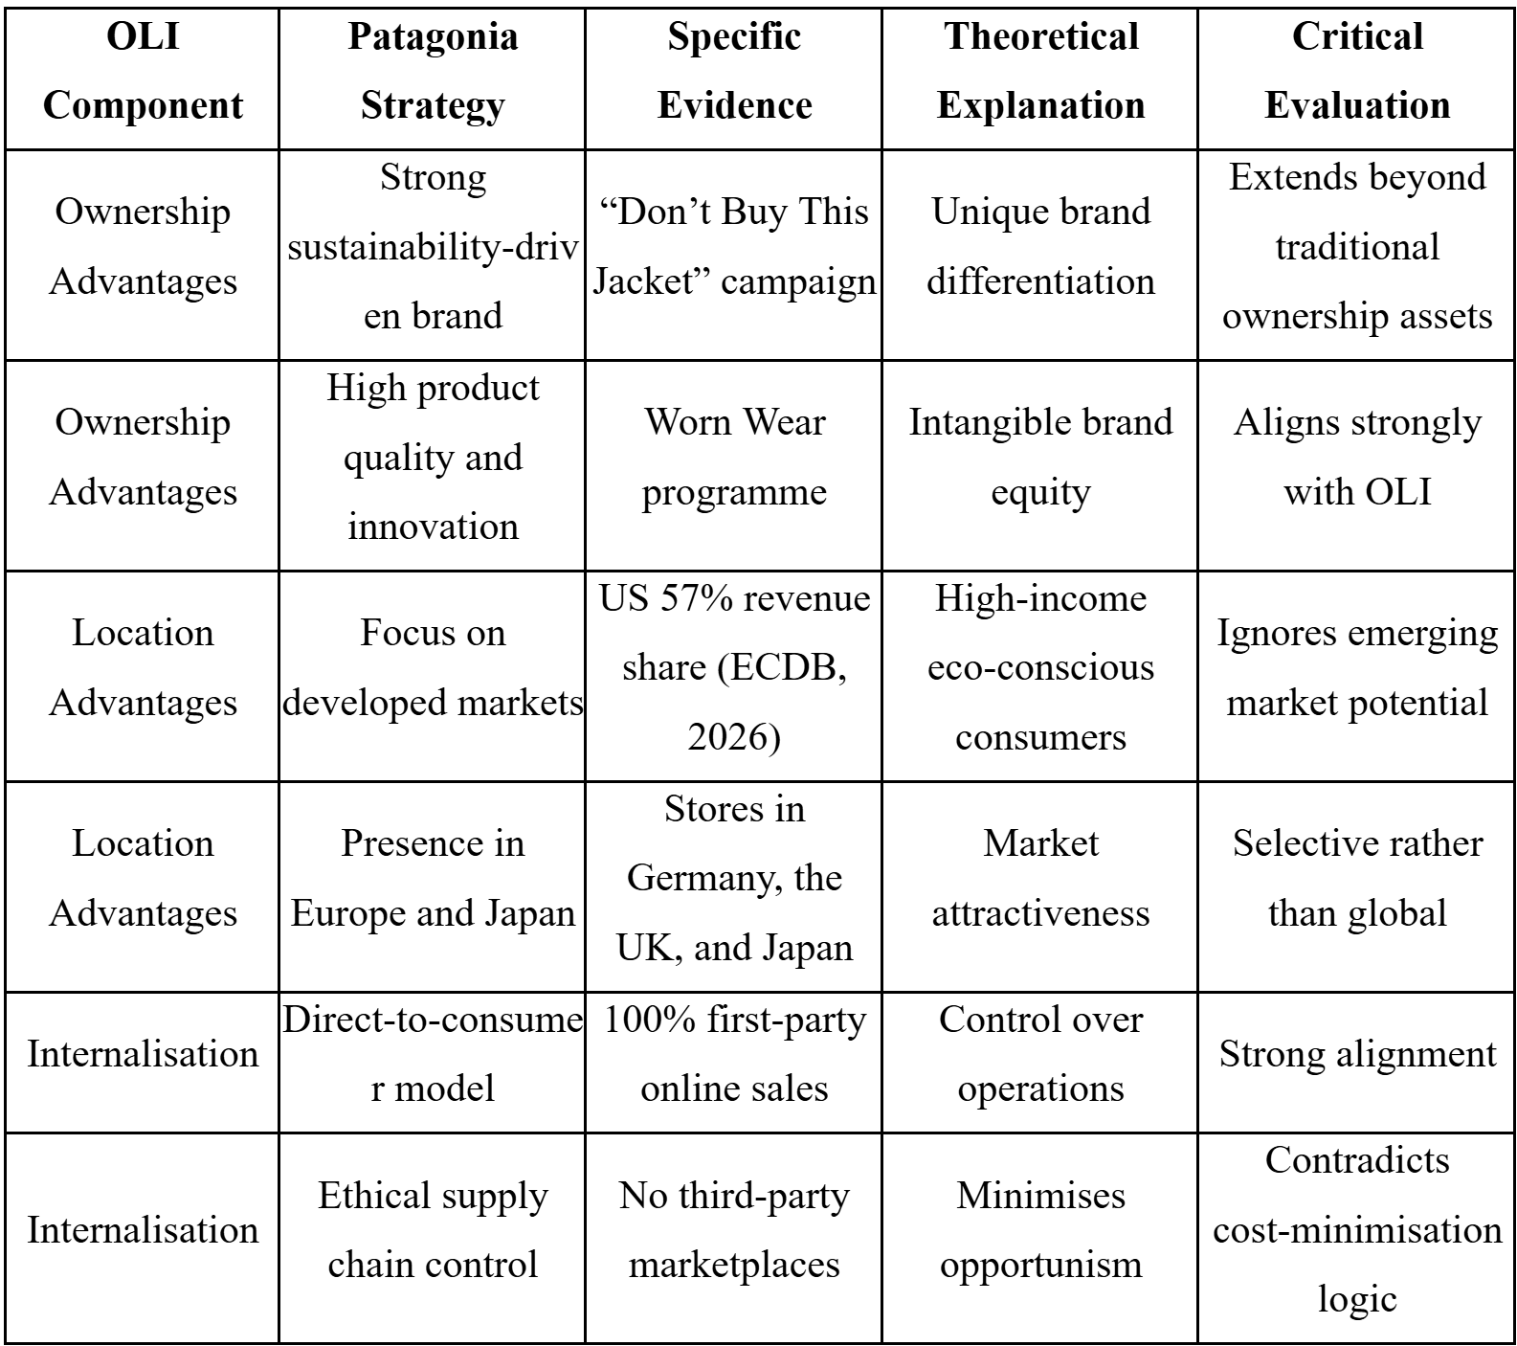
Table 2: Staged International Expansion under the Uppsala Model
(Source: Author)

3.3 Market Selection Strategy
The United States revenue consists of 57 economies; still, Patagonia focuses on sustainability-oriented ones (ECDB, 2026). The major markets are Japan, Germany, the United Kingdom and France. Ensuring that these markets are very sensitive to environmental awareness and have high purchasing power. Critics blame niche focus as a restraint to growth in emerging consumer markets.

References
Au-Yeung, A. (2020) Outdoor Clothing Chain Patagonia Starts Selling Online Again After Unusual Decision to Pause Its E-Commerce Due to Coronavirus Pandemic. Available at: https://www.forbes.com/sites/angelauyeung/2020/04/23/outdoor-clothing-chain-patagonia-yvon-chouinard-starts-selling-online-again-after-unusual-decision-to-pause-its-e-commerce-due-to-coronavirus-pandemic/ (Accessed: 1 May 2026).
Dataintelo (2026) Global Sustainable Fashion Market Report. Available at: https://dataintelo.com/report/global-sustainable-fashion-market (Accessed: 1 May 2026).
ECDB (2026) Patagonia Retailer Sample Data. Available at: https://ecdb.com/resources/sample-data/retailer/patagonia (Accessed: 1 May 2026).
ECDB (2026) Patagonia Retailer Sample Data. Available at: https://ecdb.com/resources/sample-data/retailer/patagonia (Accessed: 1 May 2026).
Patagonia (2025) Climate Risk Report FY25. Available at: https://www.patagonia.com/on/demandware.static/-/Library-Sites-PatagoniaShared/default/dwc1135e01/slots/RMA/PAT_FY25_ClimateRiskReport-122225-v2.pdf (Accessed: 1 May 2026).
Patagonia (2026) Owned and Operated Facilities. Available at: https://eu.patagonia.com/hr/en/where-we-do-business/owned-and-operated.html (Accessed: 1 May 2026).
Solberg, C.A. and Durrieu, F. (2022). ‘Patterns of international marketing strategy’, Journal of Business & Industrial Marketing, 38(7). Available at: https://doi.org/10.1108/jbim-02-2022-0091

